SQL Speedy Work

Overview:

The primary keys for each table was the Hospital_ID and Doctor_ID respectively. Both were set to Auto-Increment as each new value was added. Every other column in both tables was set to not null apart from “Experience”. Values were then added to the Experience column.

In order to link both tables together, a foreign key needed to be created between 2 common columns. The foreign key assigned here was the Hospital_ID. This will allow anyone who wants to find out information about an assigned doctor and their respective hospital to be found out more easily, thus linking the tables.

# Hospital Table

Doctor Table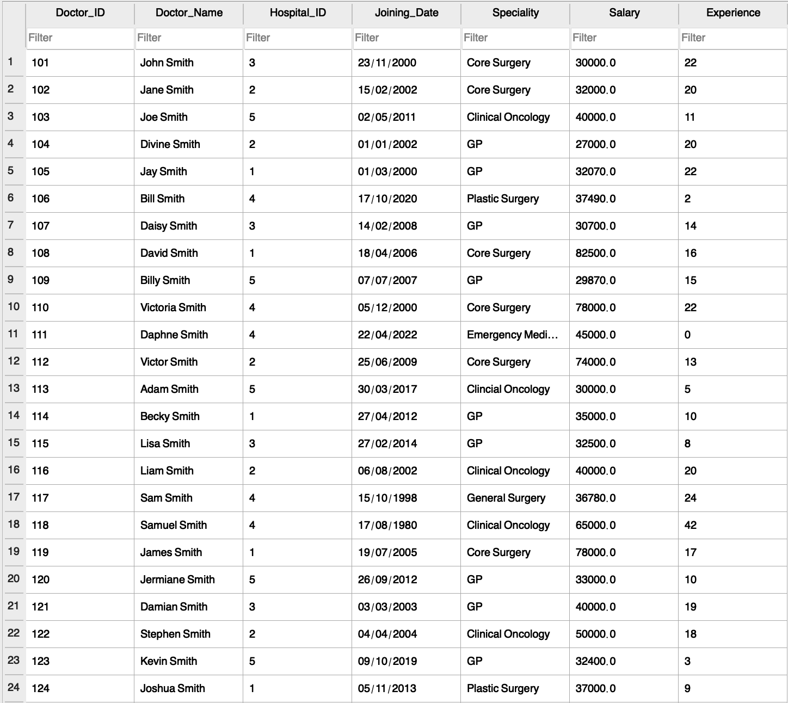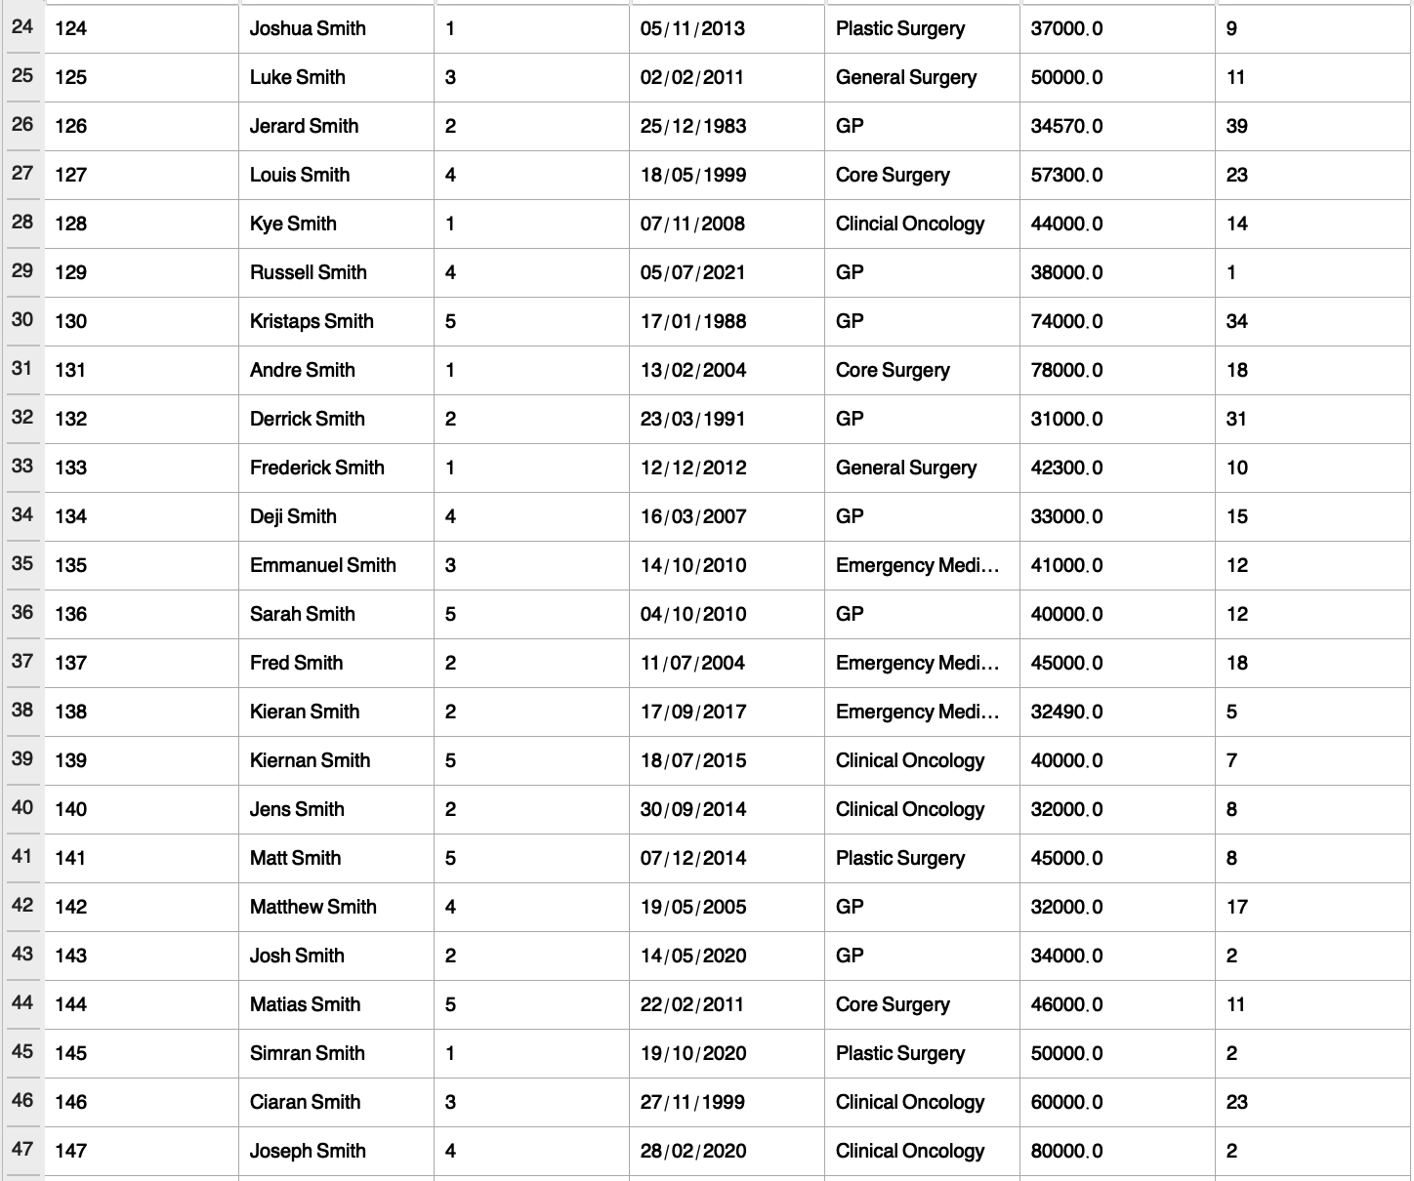

Task: Get the list of the doctors as per given specialty and salary

Task: Get the list of the doctors from a given hospital

Queries:

﻿RAGMA foreign_keys = '1';

PRAGMA database_list;

SELECT type,name,sql,tbl_name FROM "main".sqlite_master;

PRAGMA encoding

PRAGMA foreign_keys = '1';

PRAGMA case_sensitive_like = '0';

PRAGMA temp_store = '0';

PRAGMA wal_autocheckpoint = '1000';

PRAGMA synchronous = '2';

PRAGMA auto_vacuum

PRAGMA automatic_index

PRAGMA checkpoint_fullfsync

PRAGMA foreign_keys

PRAGMA fullfsync

PRAGMA ignore_check_constraints

PRAGMA journal_mode

PRAGMA journal_size_limit

PRAGMA locking_mode

PRAGMA max_page_count

PRAGMA page_size

PRAGMA recursive_triggers

PRAGMA secure_delete

PRAGMA synchronous

PRAGMA temp_store

PRAGMA user_version

PRAGMA wal_autocheckpoint

SELECT 'x' NOT LIKE 'X'

SELECT COUNT(*) FROM (SELECT "_rowid_",* FROM "main"."Doctors" ORDER BY "_rowid_" ASC);

SELECT "_rowid_",* FROM "main"."Doctors" ORDER BY "_rowid_" ASC LIMIT 0, 49999;

SELECT COUNT(*) FROM (SELECT "_rowid_",* FROM "main"."Doctors" ORDER BY "_rowid_" ASC);

SELECT "_rowid_",* FROM "main"."Doctors" ORDER BY "_rowid_" ASC LIMIT 0, 49999;

SELECT "_rowid_",* FROM "main"."Doctors" ORDER BY "_rowid_" ASC LIMIT 0, 49999;

SELECT COUNT(*) FROM (SELECT "_rowid_",* FROM "main"."Doctors" ORDER BY "_rowid_" ASC);

SELECT COUNT(*) FROM (SELECT "_rowid_",* FROM "main"."Doctors" ORDER BY "_rowid_" ASC);

SELECT "_rowid_",* FROM "main"."Doctors" ORDER BY "_rowid_" ASC LIMIT 0, 49999;

SELECT COUNT(*) FROM (SELECT "_rowid_",* FROM "main"."Hospital" ORDER BY "_rowid_" ASC);

SELECT "_rowid_",* FROM "main"."Hospital" ORDER BY "_rowid_" ASC LIMIT 0, 49999;

SELECT COUNT(*) FROM (SELECT "_rowid_",* FROM "main"."Hospital" ORDER BY "Hospital_ID" DESC);

SELECT "_rowid_",* FROM "main"."Hospital" ORDER BY "Hospital_ID" DESC LIMIT 0, 49999;

SELECT "_rowid_",* FROM "main"."Hospital" ORDER BY "Hospital_ID" ASC LIMIT 0, 49999;

SELECT COUNT(*) FROM (SELECT "_rowid_",* FROM "main"."Hospital" ORDER BY "Hospital_ID" ASC);

SELECT "_rowid_",* FROM "main"."Doctors" ORDER BY "_rowid_" ASC LIMIT 0, 49999;

SELECT COUNT(*) FROM (SELECT "_rowid_",* FROM "main"."Doctors" ORDER BY "_rowid_" ASC);

SELECT COUNT(*) FROM (SELECT "_rowid_",* FROM "main"."Doctors" ORDER BY "_rowid_" ASC);

SELECT "_rowid_",* FROM "main"."Doctors" ORDER BY "_rowid_" ASC LIMIT 0, 49999;

SELECT "_rowid_",* FROM "main"."Hospital" ORDER BY "Hospital_ID" ASC LIMIT 0, 49999;

SELECT COUNT(*) FROM (SELECT "_rowid_",* FROM "main"."Hospital" ORDER BY "Hospital_ID" ASC);

SELECT "_rowid_",* FROM "main"."Doctors" ORDER BY "_rowid_" ASC LIMIT 0, 49999;

SELECT COUNT(*) FROM (SELECT "_rowid_",* FROM "main"."Doctors" ORDER BY "_rowid_" ASC);